**Analyzing Top-Down Data in Proteoform Suite**

1. Under Load Options, select Standard.

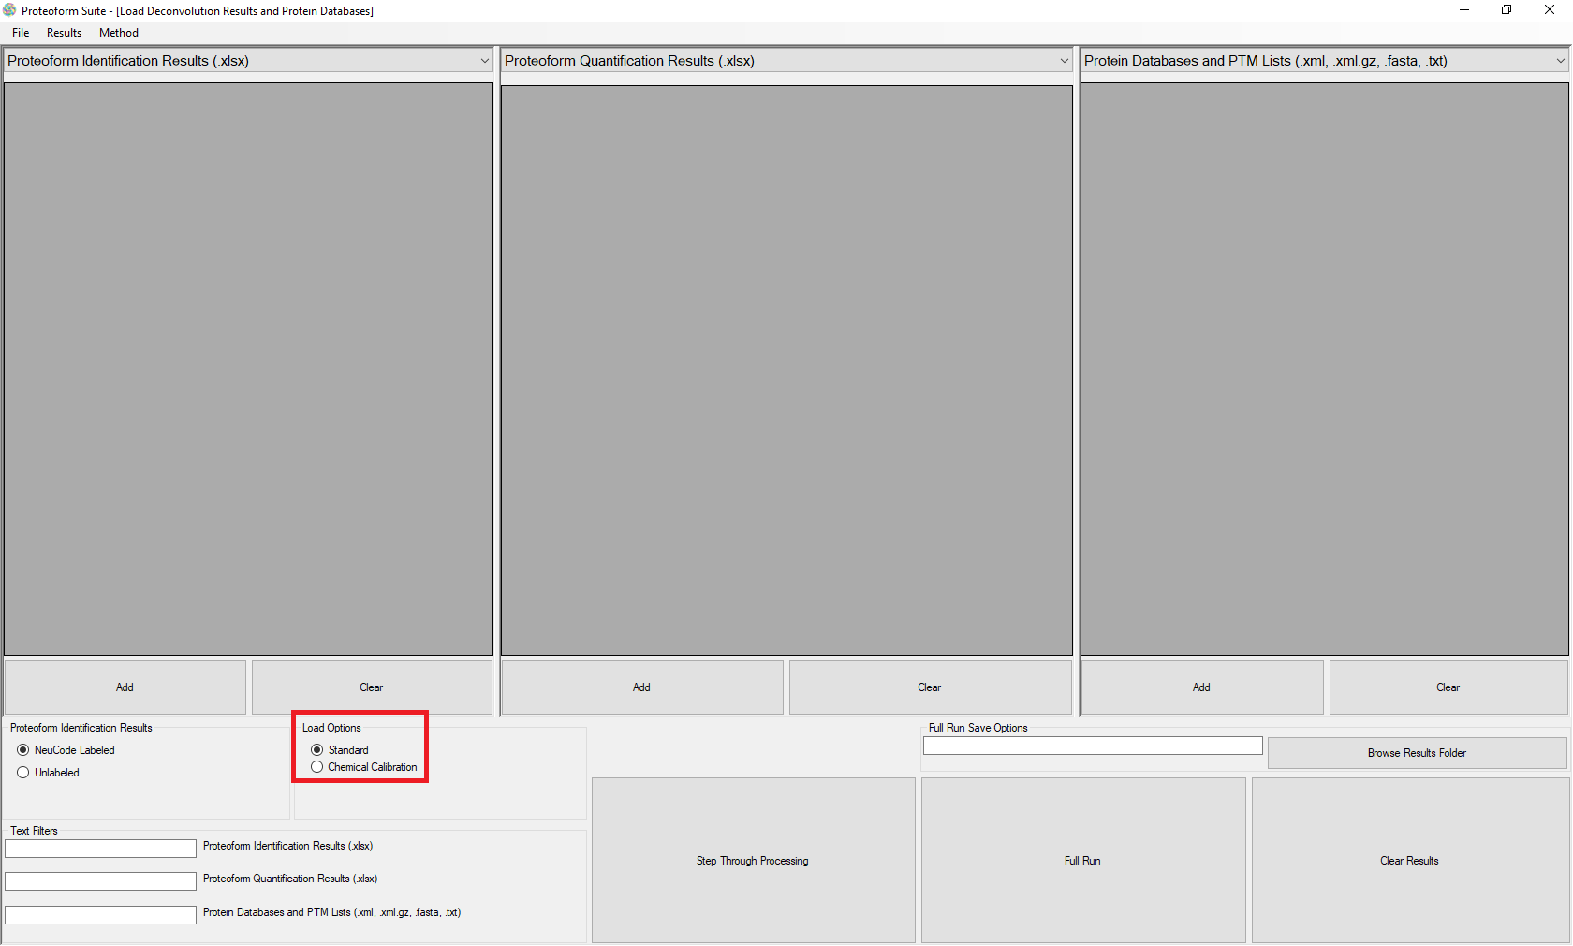

1. Under Proteoform Identification Results, select Unlabeled.

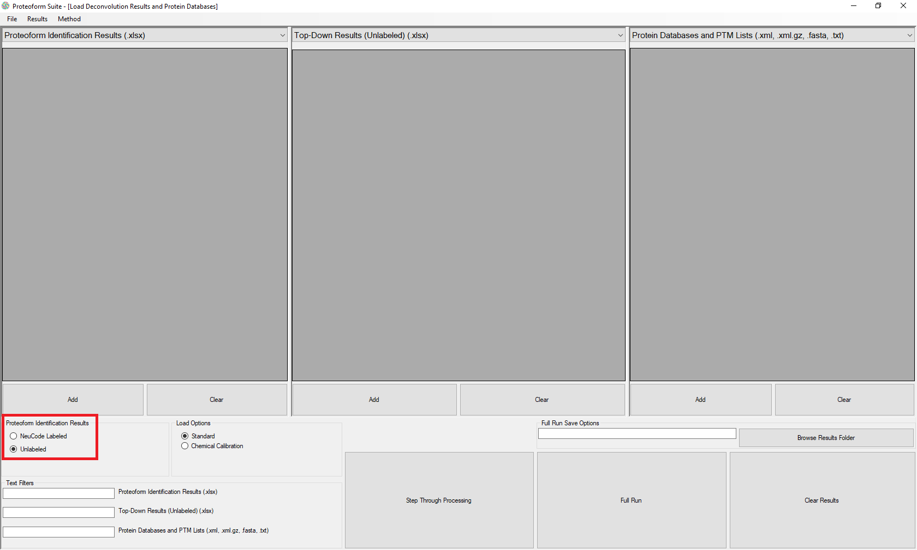

1. Click the Add button under the left grid view for “Proteoform Identification Results (.xlsx)”. Select all .xlsx files in the folder calibrated_identification_files.
2. Click the Add button under the middle grid view for “Top-Down Results (Unlabeled) (.xlsx)”. Add the file B7A_hits_5%FDR_calibrated.xlsx.
3. Click the Add button under the right grid view for “Protein Databases and PTM lists (.xml, .xml.gz, .fasta, .txt)”. Add all files in the folder proteoform_databases_yeast.
4. Click the button Full Run.

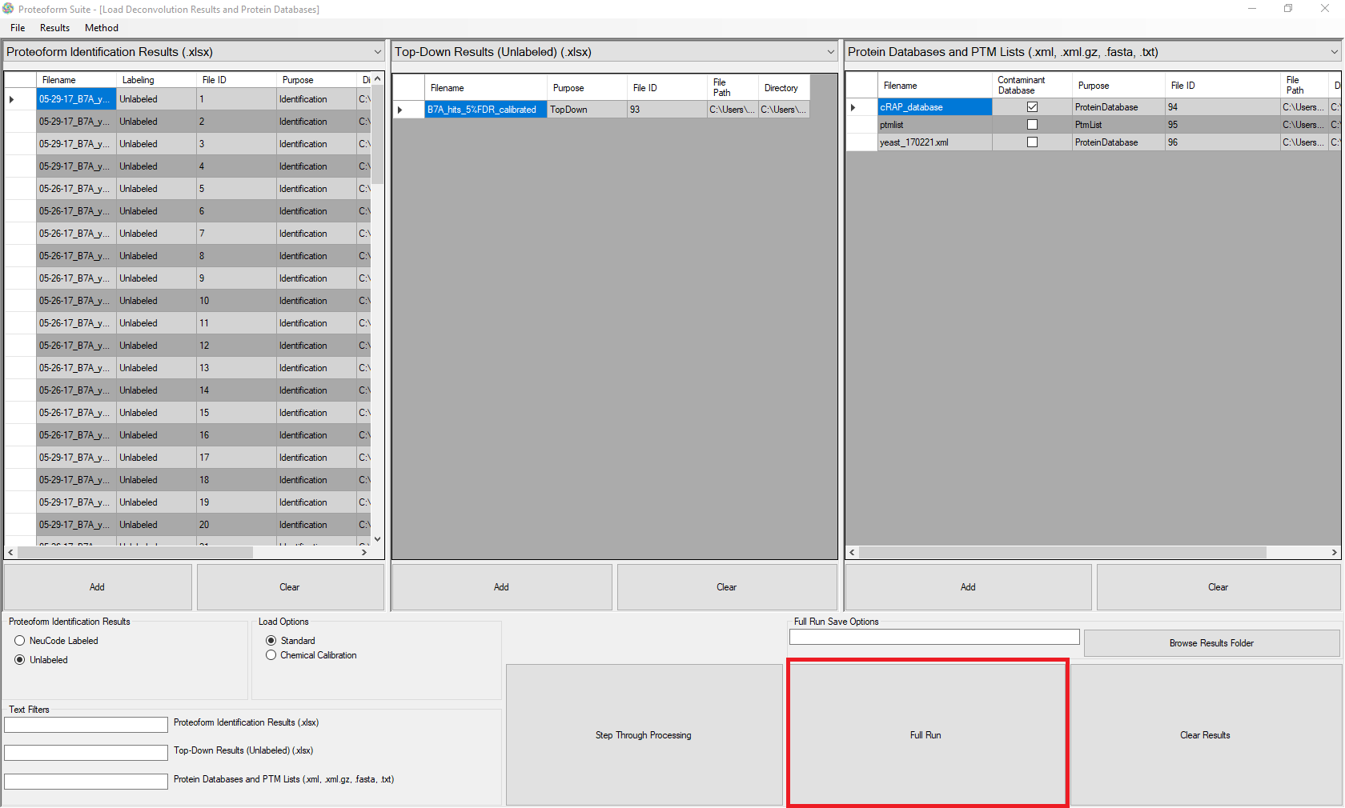

1. A message box will ask “Use presets for this Full Run?”. Select Yes, then select the method loaded in this folder called “Top-Down_ProteoformSuite_example_method.xml”
2. A message box will ask “Add files at the listed path if they still exist?” If you would like files specified in the method selected to be added, select Yes. Note that in this tutorial, we have added all files necessary so either Yes or No will yield the same result.
3. A message box will ask “Choose a results folder for this Full Run?” If you select Yes, you can choose a folder on your computer to automatically save results. Otherwise, you can select No.
4. The program will now automatically run. This can take up to an hour, depending on the parameters and computer used.
5. You can use the Results tab to navigate through the different results pages. If you change parameters, you may need to click a button on the page to re-compute. If any subsequent pages need to be recomputed, they will automatically clear.

